PHASE 6 – PROJECT TESTING

6.1 Introduction
Testing was performed to verify that PocketSmart AI functions correctly and that the major application modules work as expected.

6.2 Testing Objectives
The main testing objectives are:
- Verify user authentication.
- Verify dashboard access.
- Verify budget input.
- Verify recommendation generation.
- Verify result display.
- Verify database operations.
- Verify history/recent plans.
- Identify and correct application errors.

6.3 Testing Environment
Testing was performed using the developed application, its configured Python environment, SQLite database, FastAPI backend, and web browser.

6.4 Functional Testing
Functional testing verifies whether each feature performs its intended operation.

6.5 Authentication Testing
The login and registration functionality was tested using valid inputs.
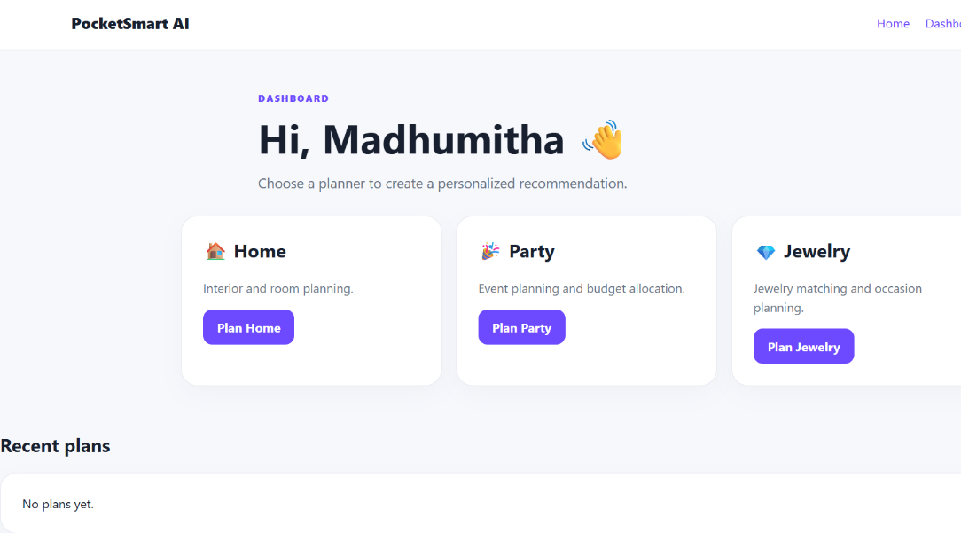

6.6 Dashboard Testing
After successful authentication, dashboard access was verified.

6.7 Budget Input Testing
The budget input functionality was tested by entering valid budget information.
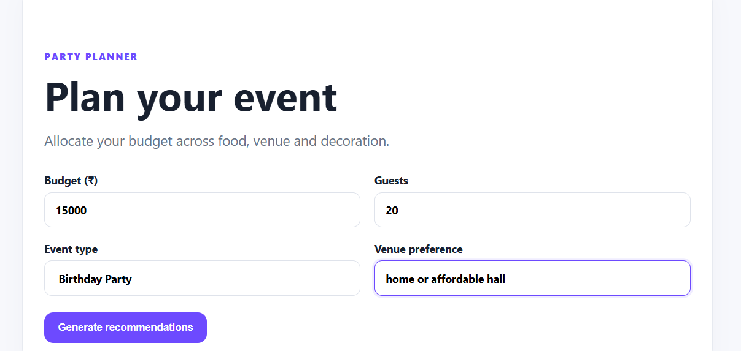

6.8 Recommendation Testing
The recommendation functionality was tested by submitting valid requirements and requesting recommendations.
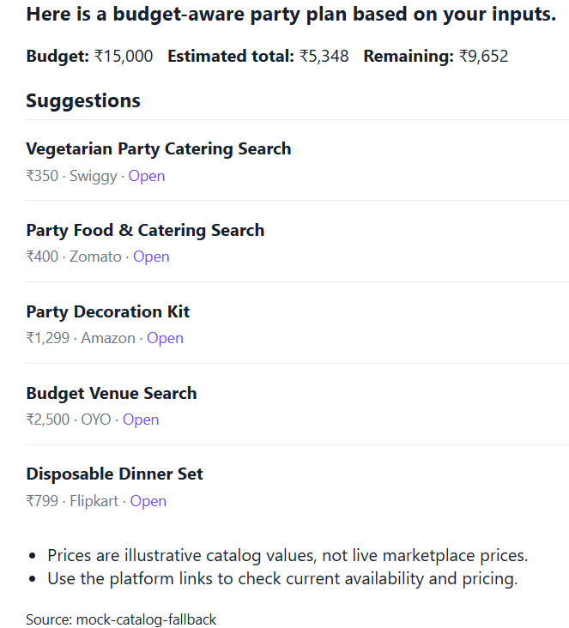

6.9 Recommendation Result Testing
The system output was verified after the recommendation request was processed.

6.10 History Testing
The recent plans/history functionality was tested to verify that previous recommendation information could be accessed.
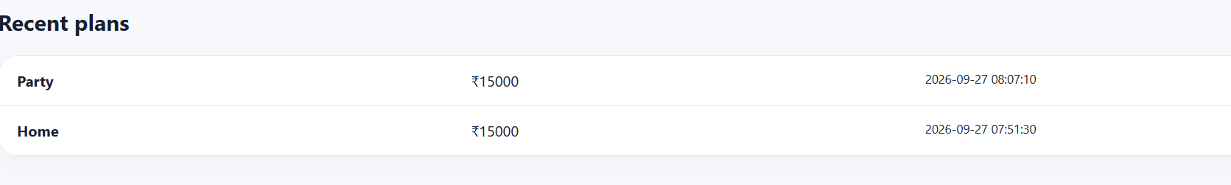

6.11 Test Case Table
Test ID | Feature | Test Input | Expected Result | Actual Result | Status
TC01 | Registration | Valid user details | Account created | Account created | Pass
TC02 | Login | Valid credentials | User logged in | User logged in | Pass
TC03 | Dashboard | Logged-in user | Dashboard displayed | Dashboard displayed | Pass
TC04 | Budget Input | Valid budget | Budget accepted | Budget accepted | Pass
TC05 | Recommendation | Valid requirements | Recommendations generated | Recommendations generated | Pass
TC06 | Result Display | Generated result | Result displayed | Result displayed | Pass
TC07 | History | Existing recommendation | Previous plan displayed | Previous plan displayed | Pass

6.12 Error Handling
Invalid or incomplete inputs were considered during testing. The application was checked to ensure that incorrect inputs do not cause unexpected application behavior.
[Not tested-no validation error screenshot available]

6.13 Testing Result
The major application functions were tested through the browser and backend environment. The successful test cases demonstrate that the implemented workflow operates as expected.

6.14 Testing Summary
Testing helped verify the application's authentication, user input, recommendation generation, result display, and history-related functionality

